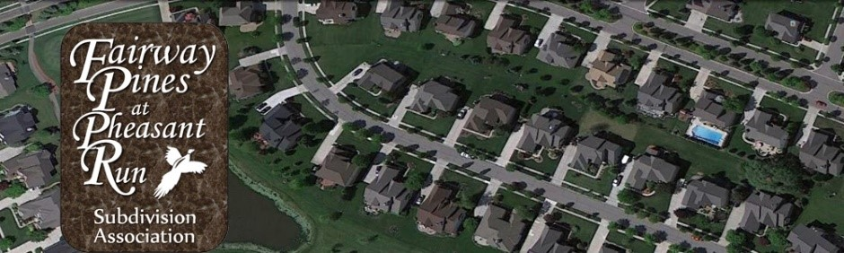

Fairway Pines at Pheasant Run Homeowners Association
Annual Homeowners’ Meeting Minutes
November 7, 2023
6:30 pm – 8:00 pm
Canton Township Administration Building, Meeting Room A

Call to Order President Jon A.
Meeting was called to order at 6:46 pm by Jon Anderson
Approval of Agenda President Jon A.
The agenda was reviewed and approved by unanimous consent.
Introduction of Board Members President Jon A.
- Jon Anderson, President
- Gelita Maxwell, Treasurer
- Lana Levens, Secretary
- Vacant, PRRMA Representative
- Michael Carter, Board Member
- Jon Anderson, Architectural Review
All board members were introduced and shared their roles/responsibilities.
Treasurer Report Treasurer Gelita M.
- There were several unexpected expenses this year.
- PRRMA proposing a 10% increase; we will know more about this at the next PRRMA meeting and will help determine if a dues increase is needed or not.
- More expensive for tree trimming
- Snow Removal – changed companies this year. The previous company was on retainer, and we experienced several issues. We will monitor the relationship with the new company and discuss performance at the end of the season.
- Electric DTE – turned the power off at the main entrance; had to pay the bill and determined meter didn’t belong to us and we need to sort out who owns the meter and how to recoup our money back from paying the DTE bill.
Delinquent Accounts Update Tom Gamache
- This continues to be an ongoing project but we are in good shape with the exception of a couple of longstanding delinquencies that we continue to manage.
General Announcements/Updates President Jon A.
- New Board Officers needed
- Help with collecting dues payments, check the PO Box
  - Hadyn Notestine was previously responsible for collecting the dues payments, tracking payments, depositing dues payments in our Chase bank account and regularly checking our PO Box. Hadyn moved out of the Fairway Pines Subdivision in August 2023 and resigned from his position.
  - As a result of Hadyn’s resignation, the board discussed and approved Wasim Urka to replace Hadyn Notestine during our November 7th Annual Homeowners’ Meeting.
  - The board also approved removing Hadyn Notestine from the Chase Bank account and adding Wasim Urka with the same rights and privileges as Hadyn.
- Landscaping, sprinklers and snow removal
- Covenants and Restrictions and violations
- Ice Storm and Tree Issues
- Architectural Review Report
- Holiday decorations
- Handling of snow contractor during winter months
- Monitor the pear trees in the sub
Questions/Comments from Homeowners
- If there is not sufficient time to address all comments, please e-mail questions/comments to info@fairwaypinescanton.com
Meeting adjournment
Meeting was adjourned at 7:56 pm

