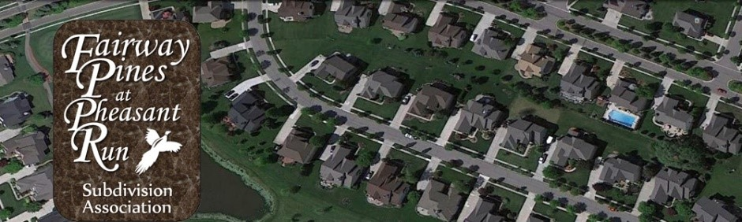

Fairway Pines at Pheasant Run
Board of Directors Meeting Minutes
October 16, 2023

Call to Order
- Meeting was called to order at 6:15 pm.
- Meeting Attendees: Jon Anderson, Gelita Maxwell, Lana Levens and Michael Carter

Approval of Agenda
- Agenda was unanimously approved as is by all board members present.

Board Updates Jon A.
- Current condition of the subdivision – need to address issues of lawn maintenance and rules around trimming trees, storm drains not being cleared
- Suggestion to have Oakley clean storm drains – should this be addressed with PRRMA? How many drains do we have?
- 20-30 letters early in the year for grass and weeds

PRRMA Report
Jon attended the last two meetings
An emergency meeting was held after the Tornado hit. Any trees that covered the roads, they got rid of them, but we are on our own with the trees to cut them down. We had to cover those out of our HOA budget
Next meeting is November 14 (second Tuesday of the month); on the agenda for a discussion regarding a meter that we have been paying for and we shouldn’t have

Architectural Review Report Jon A.
- Approved a deck on Augusta
- Window replacement

Treasurer Report Gelita M.
Budget: $2300 down on the budget like tree budget
Tree expenses this year were $15,500 and we budgeted $3,200
$25K in the checking and $50K in our money market account
New/Misc. Business

Next Meeting: All Homeowners Meeting, November 7, 2023 at 6:30 pm
Meeting was adjourned at 7:40 pm

