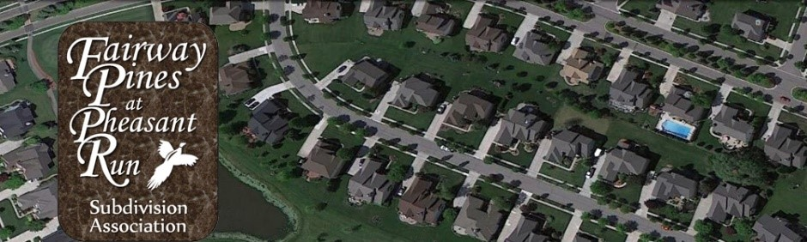

Fairway Pines at Pheasant Run Homeowners Association
Annual Homeowners’ Meeting Minutes
November 15, 2022
6:00 pm – 8:00 pm
Canton Township Administration Building, Meeting Room A

Call to Order President Jon A.
- Meeting was called to order at 6:03 pm
Approval of Agenda President Jon A.
- Motion was made by Tom Gamache
- Second by Gelita Maxwell
- Approval by consent of attendees
Introduction of Board Members President Jon A.
- Jon Anderson, President
- Gelita Maxwell, Treasurer
- Lana Levens, Secretary
- Mike Dawwas, PRRMA Representative
- Jon Anderson, Architectural Review
General Announcements/Updates President Jon A.
- Overview of board responsibilities
  - Maintain common areas for the entire subdivision; appearance is important in maintaining our residential area
- New Board Officers needed
  - If anyone is interested, we need to have a total of five (5) board members and there are currently four (4). We have had board turnover over the past few years and our longest tenured board members have stepped down.
- Landscaping, sprinklers and snow removal
  - Landscaping: (Oakley) has been our contractor for several years. He does ours and neighboring subs as well. Provides a continuous look across subs
  - Sprinklers: Oakley previously maintained sprinklers; moved to Pyramid sprinklers in 2022; 2021 we had a leak on the main valve; came out and repaired the leak at a fair rate; completed the start up in the spring of 2022 and completed $3,000 worth of repairs this year for updates. Some issues with the timing of zones on Glengary. One zone on Glengary where we had to update the zones to not lose the landscaping due to non-watering
  - Snow Removal: We have had a number of issues with this contractor and we have voiced our complaints and expectations; they should plow full width of the road, not rip up grass or push the snow into piles but we have to keep an eye on him.
  - PRRMA: Road maintenance; maintains roads in all three subs out here; we pay $105K to PRRMA who maintains the roads, sidewalks; PRRMA also covers Summit Parkway; last year the begin expense was sidewalks; there is a strict guideline on what can be repaired and when after assessments are made; should be doing another assessment again next year to see if there are any that fall out of Canton code. They completed minor patching/potholes. Biggest update was the stone wall at the entrance of Glengary, the lighting is still being worked on; middle is back on, and the two sides are out now
- Covenants and Restrictions and violations
  - These are etched in stone and provides a guideline on what can and cannot be done throughout the subdivision. We can’t change them or update them.
  - Jon has the power to enforce the contents of the covenants and restrictions. 97 letters have been sent since 2020 for violations. The biggest violation is weeds, grass and 7ft tree trimming violation towards the curb, trash cans left outside, RV storage, etc.
  - Violations have reached a point where we have several habitual offenders (4-5 letters; contacted ordinance enforcement officers and makes a halfhearted attempt; it is within our power to force it more stringently; board voted in 2021 to institute fine system but haven’t implemented them because the board is trying to be punitive
  - Homeowner suggestion to have a policy for everyone not just based on the worse offender
  - $100 fine for first violation (correct within 2 weeks)
  - Develop a consistent policy for everyone as a basis;
  - Document in letter (and pictures); will need to go to small claims court
- 2023 Tree Trimming needs
  - Canton Township Ordinance needs a 7ft clearance above the sidewalk. The board can’t take it on; everyone will get a notice about the trees and if it doesn’t get taken care of; follow-up and a fine on that. Easement between sidewalk and street
  - Grass standard is 5 inches on the lawn
- Architectural Review Report
Treasurer Report Treasurer Gelita M.
Questions/Comments from Homeowners
- If there is not sufficient time to address all comments, please e-mail questions/comments to info@fairwaypinescanton.com

- Fountain View Parking is an issue where cars are blocked on both sides of the street and makes it difficult for Homeowners to pass through or enter driveways

Delinquencies Tom Gamache
4 outstanding payments
When paid on time we govern ourselves; when they don’t pay it goes to collection agency and law firm
2 are minimal - $111 will add to 2022 dues amounts
2 – are more long term; one has been delinquent since 2021 (owes $1,566; now owes $5,286.75) – Rickel Law Firm; one has been delinquent since 2011 (owes $14,747 collected; waived $1,900 in interest; agreed to monthly fee down to $4,117.
Association Dues Assurance Cooperation – Rickel Law Firm
Meeting adjournment
Meeting was adjourned at 8:04 pm

