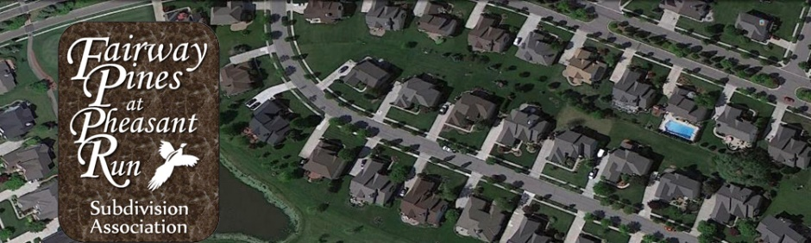
Fairway Pines at Pheasant Run
Board of Directors Meeting Agenda
November 19, 2020
Virtual Zoom Meeting
7:00pm

- Call to Order Tom G.
  - Approval of Agenda

- President’s Report Tom G.
  - Dues/Delinquent Accounts Update
  - Annual dues invoicing and distribution
  - 2021 FP website changes
  - Feedback from Newsletter

- PRRMA Report Gelita M.

- Architectural Review Report John M.

- Treasurer Report Rich R.

- New/Misc. Business
  - Next Board Meeting Date

